**HTYNJUKMUKM,**

**Name: Mohammed Ahmed Medhat Nasr Yaquob**

**Address: Department of Tropical medicine and Gastroenterology – Assiut**

**University Hospital – 71526, Assiut – Egypt**

**Telephone: +20882327543 Egypt Cellular: +201006258887 Egypt**

**E mail: mmedhat83@gmail.com**

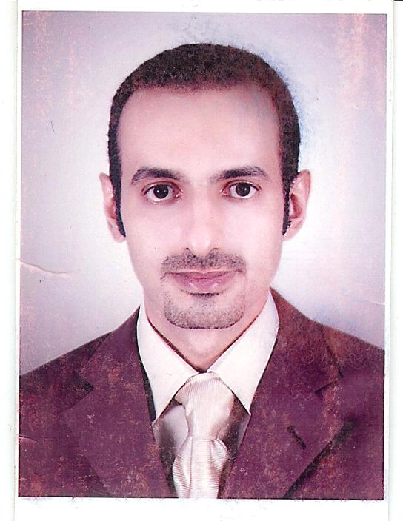

**CURRICULUM VITAE**

Personal information

|  |  |  |
| --- | --- | --- |
| **Date of Birth** | **:** | **7/5/1983** |
| **Gender** | **:** | **Male** |
| **Marital Status**  **Nationality** | **:**  **:** | **Married**  **Egyptian** |

Education

**2001-2007: M.B.B.Ch in medicine and surgery, Faculty of Medicine, Assiut University; signed up EXCELLENT with honor.**

Degrees

* **2007: M.B.B.Ch (Bachelor of Medicine) from Assiut faculty of medicine.**
* **2012: Master degree of Tropical medicine and Gastroenterology from Assiut University signed up EXCELLENT with essay titled:**

**Selection and timing of Liver transplantation among patients with chronic liver disease**

Positions

* **A. Past:** 
  + **2008-2009: House officer in Assiut University Hospitals – Egypt**
  + **2009-2012: A resident in Tropical medicine and Gasteroenterology Department, Assiut University Hospitals – Egypt**
* **B. Current:** 
  + **2012: Associate lecturer of and clinical fellow of Tropical medicine and Gasteroenterology - Faculty of Medicine – Assiut- Egypt.**

Summary of experience:

* **Assiut University Hospital:**
* **The gastroenterology and fever clinic in Assiut University Hospital serves Upper Egypt from Assuit to Aswan.**
* **The daily patients encountered at the clinic average 30 patients/day. During my service in the department, I covered general, as well as specialized clinics.**
* **Website: www.aun.edu.eg/fac_med/hospital/index.html**
* **I performed the following clinical activities in Assiut University Hospital (March 2008 up till now):**
* **Clinical experience;**

**Attended a training for 6 weeks in Liver Transplantation unit in Ain Shams Specialized Hospital.**

**Attended interventional sonar in the form of:**

* **Ethanol injection of HCC.**
* **Aspiration of liver abscess.**
* **Radiofrequency of HCC.**
* **Liver biopsy.**

**Performed:**

* **130 cases of abdominal paracentesis.**
* **Abdominal ultrasound for 350 cases.**
* **Training for upper endoscopy in Endoscopy unit in Assiut University Hospital.**
* **Doing more than 250 upper endoscopies including sclerotherapy and band ligation.**
* **Doing about 84 colonoscopies including doing polypectomy.**
* **48 liver biopsy**
* **8 cases of ethanol injection for HCC.**
* **Teaching:**

**Teaching Experience and Academic Services:**

* **My duties in Assiut University hospital included supervising junior colleagues in the clinic and during clinical practice in our department, clinical rounds for the 5th year medical students, as well as conducting teaching sessions interns and younger residents of our department as well as tropical residents of Police hospitals.**
* **I regularly participated in the departmental educational meetings, audit meetings, and regional scientific meetings.**
* **I also actively share in preparing and presenting lectures for the weekly scientific meetings and annual basic and clinical science courses in the department.**
* **Public service:**
* **I have been regularly participating for 4 years in Assiut University Hospital annual one day camps for the under-served urban areas of Assiut. These camps involve establishing one day polyclinics in all the major medical specialties with diagnostic facilities and non-surgical mass treatment services with an integrated referral system to the University Hospital if required.**
* **I also participated in the annual medical care program organized by the department of community medicine, which involves 6 weeks of surveying, screenings, and managing patient through a door to door visit at distant urban locations.**
* **General interests and skills**
* **Sports: Running and football.**
* **Information Technology: Application developer and programming. I attended many courses and used to give computer lectures to my colleagues in medical school.**
* **Being familiar with computer software and information technology, I’m responsible for the department e-library, submitting and revising manuscripts for faculty members and offering other computer consultations for my colleagues.**

Training Courses:

* **Medicolegal Aspects and Ethics in Medical Practice and Scientific**

**Research Course Lectures**

* **Excellent degree**
* **Medical Statistics**
* **Excellent degree**
* **Research methodology**
* **Excellent degree**
* **International Teachers Training in Medicine**
* **Student evaluation**
* **Research team management**
* **Conference organization**
* **Quality standards in teaching**
* **Research methodology**
* **Strategic planning**

Conferences and Workshops:

**Attended the following conferences:**

* **15th International Congress of ESTIP**
* **June 22-24, 2010**
* **The Egyptian society of Tropical Medicine Infectious and Parasitic Disease.**
* **17th International Congress of ESTIP**
* **June 2012**

|  |
| --- |
|  |

* **The first Egyptian organ transplant congress**
* **24th- 26th of March 2010**
* **3rd annual conference of the Egyptian Society of Liver Cancer**
* **1st - 2nd November, 2012**
* **Post Graduate course on Hepatology and Gastroenterology**
* **7th-8th December, 2012**
* **14th Workshop on therapeutic GI endoscopy**
* **9th-10th December, 2012**
* **EASIE course in interventional GI Endoscopy**
* **20th to 22nd of September, 2013**
* **Advanced GI Endoscopy and interventional radiology workshop**
* **16th & 17th of March 2014**
* **The annual International congress of Egypt for Hepatogastroenterology**
* **18th-20th of March, 2014**